MEASURING ENERGY CONSUMPTION USING REMOTE LAB

1. Introduction

- Sustainability is a key goal for KDE over the next two years. As part of this goal, KDE aims to measure the energy consumption of its software and eco-certify applications with the Blue Angel ecolabel.
- Currently, we measure the energy consumption of our software using a lab based in Berlin following the process documented in the KDE Eco Handbook (Handbook: Applying The Blue Angel Criteria To Free Software).
- The lab setup requires (i) a test PC (System Under Test) to run user-emulation scripts, (ii) a power meter to measure the energy consumption of the test PC, and (iii) another PC (Data Aggregator & Evaluator) to collect and analyze the output data. In the current setup, developers must rely on individuals in Berlin to test software for them on-site in the lab.
- This proposal aims to provide remote access to the lab in two steps: first, automating the energy measurement process, including providing a summary of the results; and second, setting up backend CI/CD integration as well as a frontend upload portal.
- By automating the process and providing remote access, we make it possible for developers to measure the energy consumption of their software from any location in the world. The increased access to the lab will enable data-driven decision-making for efficiency improvements in code and software eco-certification with agencies like the Blue Angel.

2. Project Goals

The proposed project has three main goals:
- Measurement Automation: Implement a solution where a developer provides as input three scripts (baseline, idle mode, and standard usage scenario) with a config file and automatically obtains a summary of results from OSCAR (Open source Software Consumption Analysis in R).
- Remote Access 1: Implement a CI/CD pipeline as a backend solution for performing the energy consumption measurements in the remote energy measurement lab.
- Remote Access 2: Design a frontend for authorization and inputting user data in the remote energy measurement lab.

3. Implementation

The primary goal of the project is to implement a CI/CD pipeline with jobs scheduled for each task.

Workflow: Once a reviewer approves a merge request created with the app_name/module_name of the application to test, the CI job will run. This is to ensure the security of someone making an MR which runs arbitrary code.

rules:
if: $CI_PIPELINE_SOURCE == "merge_request_event" && $CI_MERGE_REQUEST_APPROVED == "true"

The three stages that are scheduled for the CI job are:
- Build: In this stage, the app is built using Flatpak and it is exported in a remote repository. This is done to ensure security using containerization, which Flatpak offers.
- Energy_Measurement: This stage installs the Flatpak from the remote repository and uses SSH to connect to the test PC (System Under Test) to run the scripts while starting the power meter and recording the data collected in another PC (Data Aggregator & Evaluator). This stage generates log files as artifacts
- Result: In this stage, the log files are uploaded to a tool such as OSCAR to generate a report that is sent to the user.

Result
Build
Energy_Mesurement
The detailed implementation of each stage is described below:

Build:
- There is already a utility in KDE's GitLab CI to build Flatpak apps (https://invent.kde.org/sysadmin/ci-utilities/-/blob/master/gitlab-templates/flatpak.yml)
- The .gitlab-ci.yml would look something like this:

flatpak:
stage: build
image: kdeorg/flatpak-builder:latest
tags:
- Linux
variables:
FLATPAK_REPO: flatpak-repo
rules:
# Trigger the job when an MR is approved.
- if: $CI_PIPELINE_SOURCE == "merge_request_event" && $CI_MERGE_REQUEST_APPROVED == "true"
before_script:
- git clone --depth 1 https://invent.kde.org/sysadmin/ci-utilities.git
script:
# Get module name from MR title.
- export KDE_FLATPAK_MODULE_NAME=$(echo ${CI_MERGE_REQUEST_TITLE} | awk '{print $NF}' | tr '[:upper:]' '[:lower:]')
- echo "Building Flatpak app for module $KDE_FLATPAK_MODULE_NAME"
# Build and install.
- python3 -u ci-utilities/flatpak-build.py ${KDE_FLATPAK_MODULE_NAME}
# Export to Flatpak repository.
- flatpak build-export ${FLATPAK_REPO} ${KDE_FLATPAK_MODULE_NAME} ${CI_COMMIT_REF_SLUG} --force --gpg-sign=${CI_DEPLOY_KEY_NAME}
artifacts:
name: Flatpak artifacts
expose_as: Get Flatpak bundle here
when: on_success
paths:
- "${FLATPAK_REPO}/org.kde.${KDE_FLATPAK_MODULE_NAME}.flatpak"
expire_in: 14 days

- Here, the Flatpak is exported to a Flatpak repository, and the artifact is pointed to the exported Flatpak bundle in the repository under the name of org.kde.<module-name>.flatpak
- The module name is taken from the MR title, which should include the name of the Flatpak module. The title is parsed to extract the last word, which is then used as the module name. The name is also converted to lowercase, which is the convention used in Flatpak.
- We can also configure the flatpak manifest file to use config for a particular application and then build the flatpak using that manifest file.

NOTE: The repository is created outside of the job, so it is necessary to make sure it exists before running the job.

Energy_Measurement:
The components required for measuring the energy consumption of software are as follows (note that the hardware has already been set up for in-person use at the energy measurement lab in Berlin):

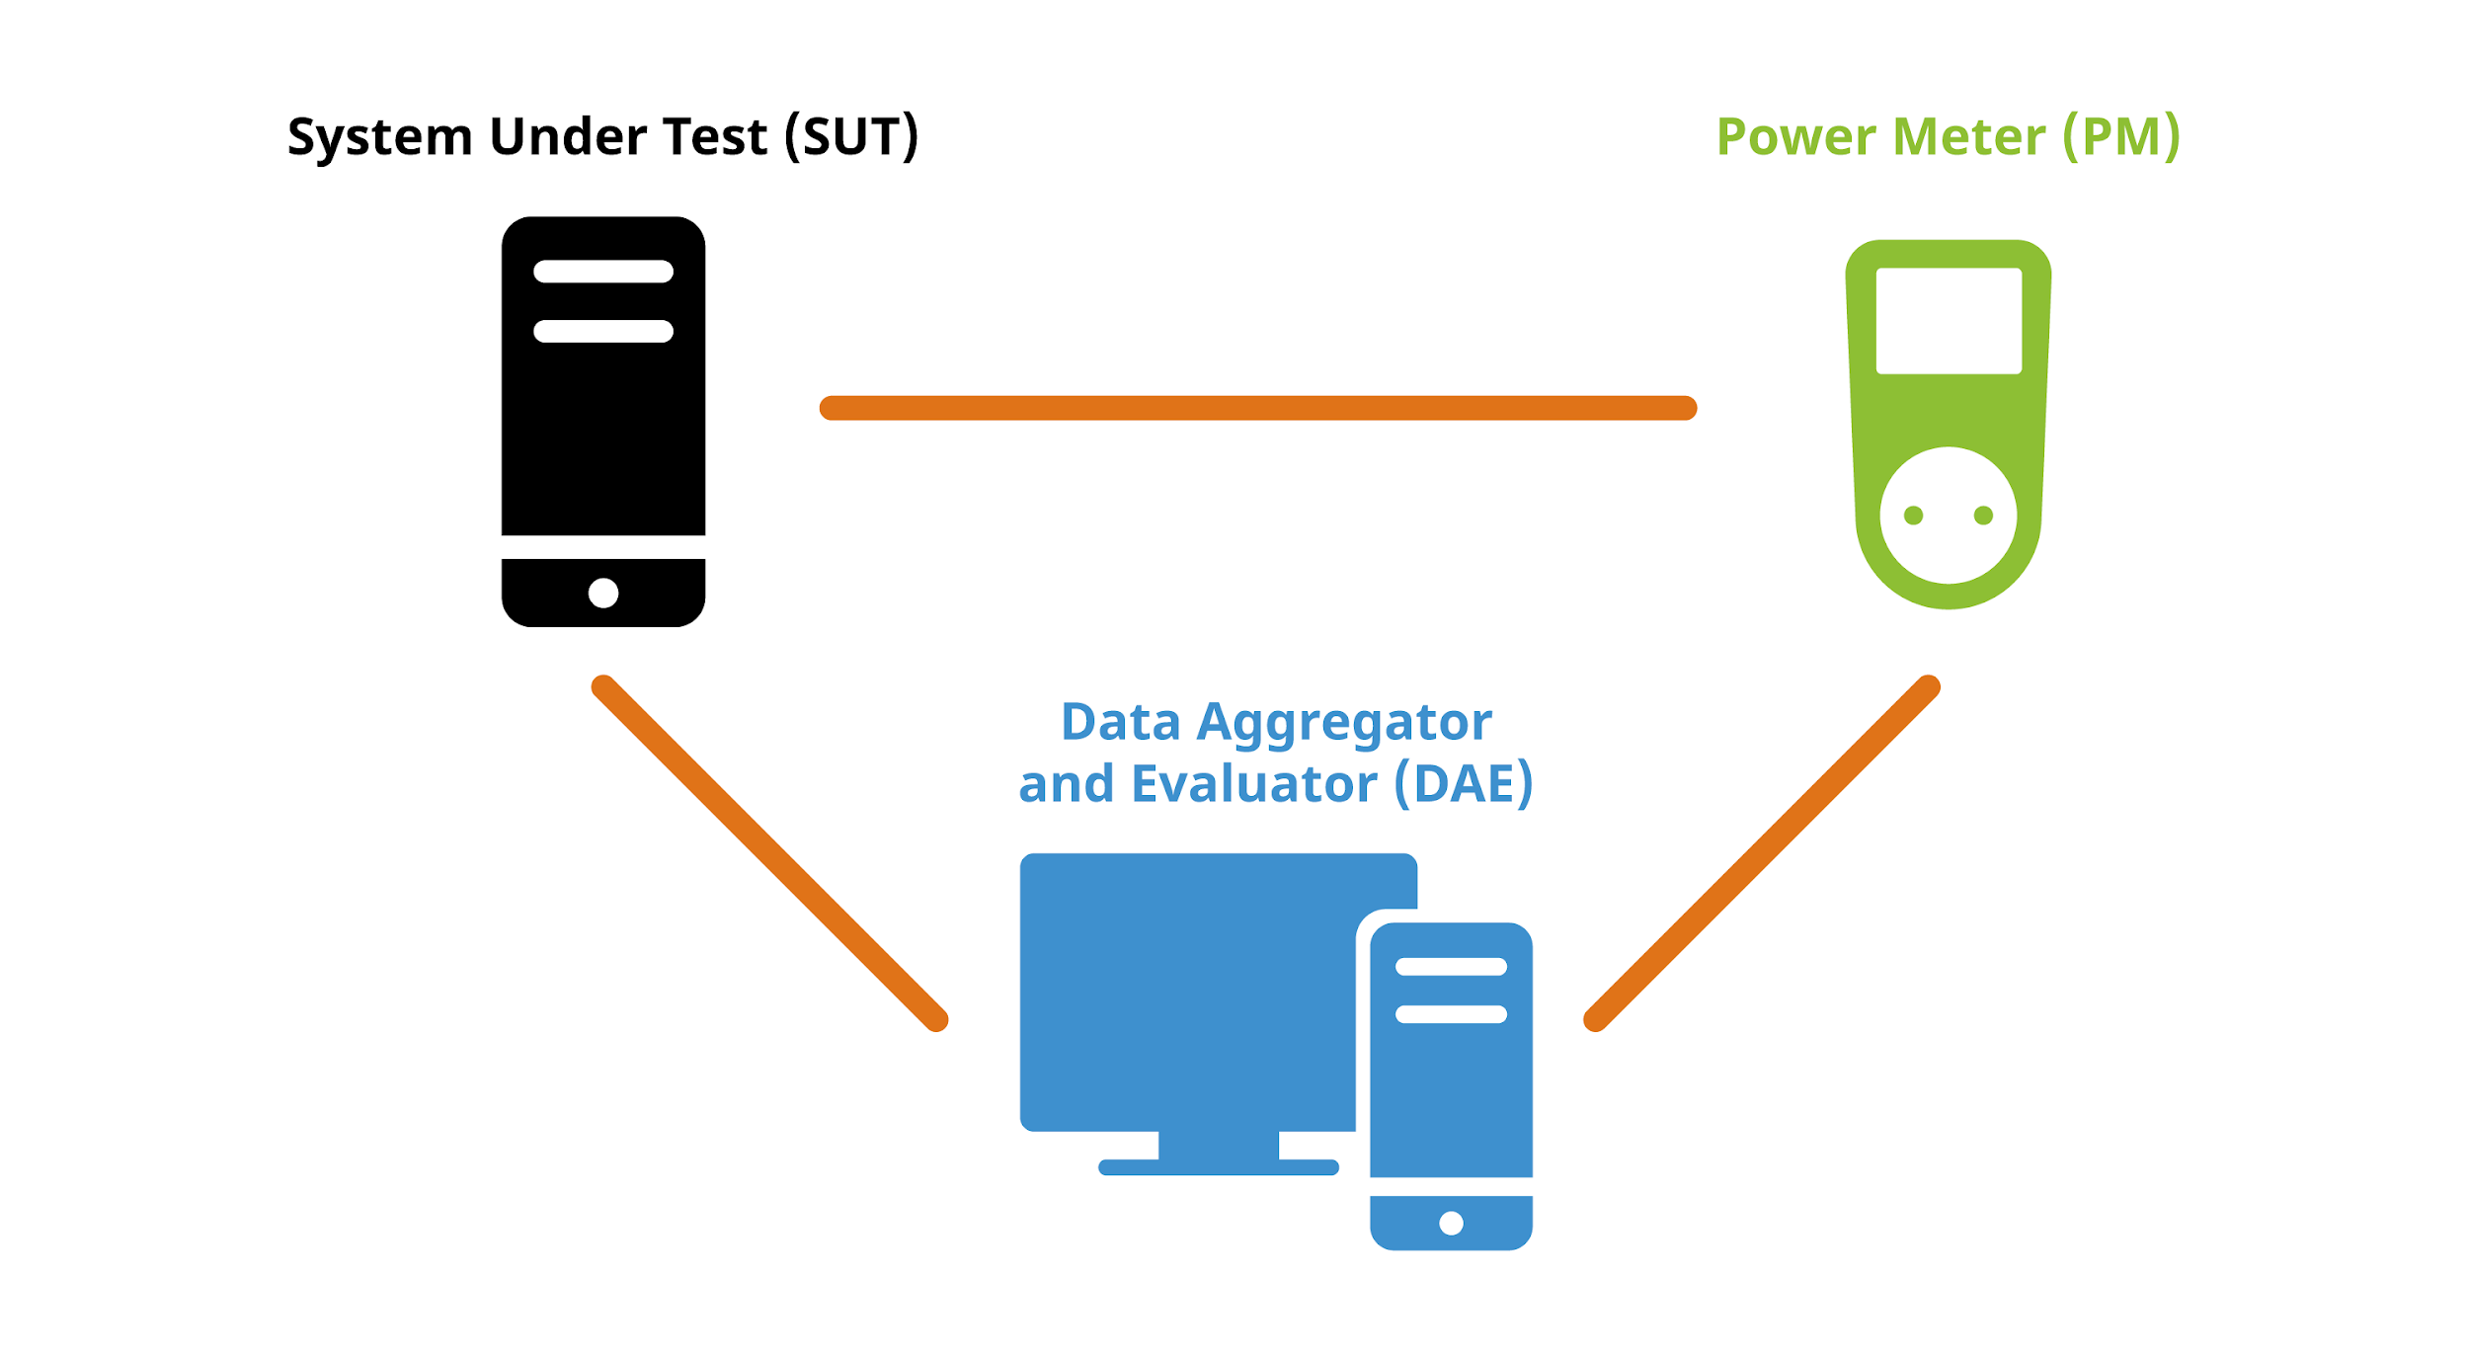

- SUT (System Under Test): The software to be measured is installed and run on the SUT. The SUT also runs the three user-emulation scripts, i.e., baseline, idle mode, and the standard usage scenario, which are prepared in advance with an automation tool such as xdotool. Moreover, the Collectl tool is installed on the SUT for collecting hardware performance data (e.g., processor and RAM utilization, hard disk activity, and network traffic).
- Power Meter: This device provides outlets for powering the computer and measuring the current during operation. It can be controlled and read via cabled Ethernet with various protocols such as SSH to control the device (https://gude-systems.com/en/products/expert-power-control-1202/#features).
- DAE (Data Aggregator & Evaluator): This component is responsible for collecting and evaluating results from both the Power Meter and SUT. A Python script to read out the data from the Gude Expert Power Control 1202 Series is available at the FEEP repository.

NOTE: It is important to note that the type of Power Meter, the software for executing standard usage scenarios, as well as the tool utilized for generating reports can be configured according to specific requirements.

To handle this CI job carefully, it is divided into three parts:

- Before_script:
  - Build Flatpak App from the remote repository and install the app on SUT
  - SSH into Power Meter and start energy consumption measurements of SUT
  - SSH into DAE and run Python script to read output from Power Meter
- Script:
  - SSH into SUT and start Collectl to collect hardware performance data
  - Run three user-emulation scripts in a chain on SUT
- After_script:
  - Get CSV log file of actions for each script (i.e., baseline, idle mode, standard usage scenario) from SUT
  - Get Collectl output CSV log file from SUT
  - Get Gude Power Meter energy consumption CSV log file from DAE
  - Create artifacts for each log file which can be re-checked to ensure accuracy or used for debugging purposes
  - Clear the logs and kill any processes and stop the PM

env:
SUT_IP: '192.168.0.10' # replace with the IP of SUT
DAE_IP: '192.168.0.20' # replace with the IP of DAE
PM_IP: '192.168.0.30' # replace with the IP of Power Meter
Energy_measurement:
stage: Energy_Measurement
tags:
- Linux
before_script:
# Checkout the code from the repository
- name: Checkout code
uses: actions/checkout@v2
# Install flatpak
- apt-get update && apt-get install -y flatpak
- flatpak remote-add --if-not-exists flathub https://flathub.org/repo/flathub.flatpakrepo
# Install the flatpak app
- flatpak install ${CI_PROJECT_NAME}.flatpak --user -y
# Start Power Meter and DAE
- ssh -o StrictHostKeyChecking=no -i sshkey.pem user@$PM_IP "start" # Using Power Meter command to start
- ssh -o StrictHostKeyChecking=no -i sshkey.pem user@$DAE_IP "python3 ~/path/to/GUDEPowerMeter.py"
script:
# Start Collectl
- ssh -o StrictHostKeyChecking=no -i sshkey.pem user@$SUT_IP "sudo collectl -sC -f ~/path/to/collectl-output.csv"
# Copy the scripts to Remote VM
- scp script1.sh script2.sh script3.sh user@remote-vm:/tmp
# Run the Scripts
- ssh -o StrictHostKeyChecking=no -i sshkey.pem user@SUT_IP 'sh /tmp/script1.sh'
- ssh -o StrictHostKeyChecking=no -i sshkey.pem user@SUT_IP 'sh /tmp/script2.sh'
- ssh -o StrictHostKeyChecking=no -i sshkey.pem user@SUT_IP 'sh /tmp/script3.sh'
after_script:
# Get log files, Collectl output and Gude Power Meter data
- scp user@$SUT_IP:~/path/to/log-files/* ./logs/
- scp user@$SUT_IP:~/path/to/collectl-output.csv ./collectl/
- scp user@$DAE_IP:~/path/to/GUDEPowerMeter.csv ./gude/
# Create artifacts
- name: Create artifacts
uses: actions/upload-artifact@v2
with:
name: Energy-Measurement-Artifacts
path: |
./logs/
./collectl/
./gude
# Clean up and stop Power Meter and DAE
- name: Clean up and stop Power Meter and DAE
run: |
ssh user@$PM_IP "stop"
ssh user@$DAE_IP "killall python3"
ssh user@SUT_IP "rm .* /tmp/ ~/path/to/logs"
rm -rf build-dir

Result:
- OSCAR (Open source Software Consumption Analysis in R) is a tool developed by Umwelt-Campus Birkenfeld for evaluating energy and hardware measurement data of a software product.
- After obtaining CSV log files for each of the three scripts from the energy measurement stage, an analysis can be run using OSCAR. This analysis includes a summary of the results and visualizations in plots.
- HTTP requests can be sent to upload the CSV files and generate the report, which is then available as an artifact.
- The reports can be used for data-driven development purposes or eco-certification with the Blue Angel.

- name: Run OSCAR analysis
run: |
CSV_FILE_PATH=/path/to/csv/files
OSCAR_API_ENDPOINT=https://example.com/api/analysis
# Send HTTP request to OSCAR API to upload CSV and generate report
curl -H "Authorization: Bearer $AUTH_TOKEN" \
-F "file=@$CSV_FILE_PATH" \
$OSCAR_API_ENDPOINT

Implementing FrontEnd for KEcoLab:
A secondary goal of the project is to implement a user-friendly front-end solution for uploading the data and getting results back.
- Developers can benefit from a user-input frontend that facilitates the process of uploading data and obtaining results.
- An uncomplicated frontend can be created to receive the script name and application version as input, and generate a Merge Request (MR) with the application name to trigger the GitLab pipeline.
- In order to integrate this frontend with GitLab, a Personal Access Token (PAT) with appropriate MR creation permissions needs to be generated on GitLab. Within the form element, the action attribute can be specified to direct to the GitLab API endpoint responsible for MR creation:

<form method="post" enctype="multipart/form-data" action="https://invent.kde.com/api/v4/projects/ (KDE’S Gitlab api) <project_id>/merge_requests?private_token=<personal_access_token>">

- Setting the title and description is possible through &title=<Application Name>&description=<Application Version>.
- Upon submission of the form, data will be transmitted to the GitLab API endpoint to create an MR with the application name as its title, the application version as its description, and the uploaded script files as its contents. GitLab will then execute the application in accordance with the established configuration.
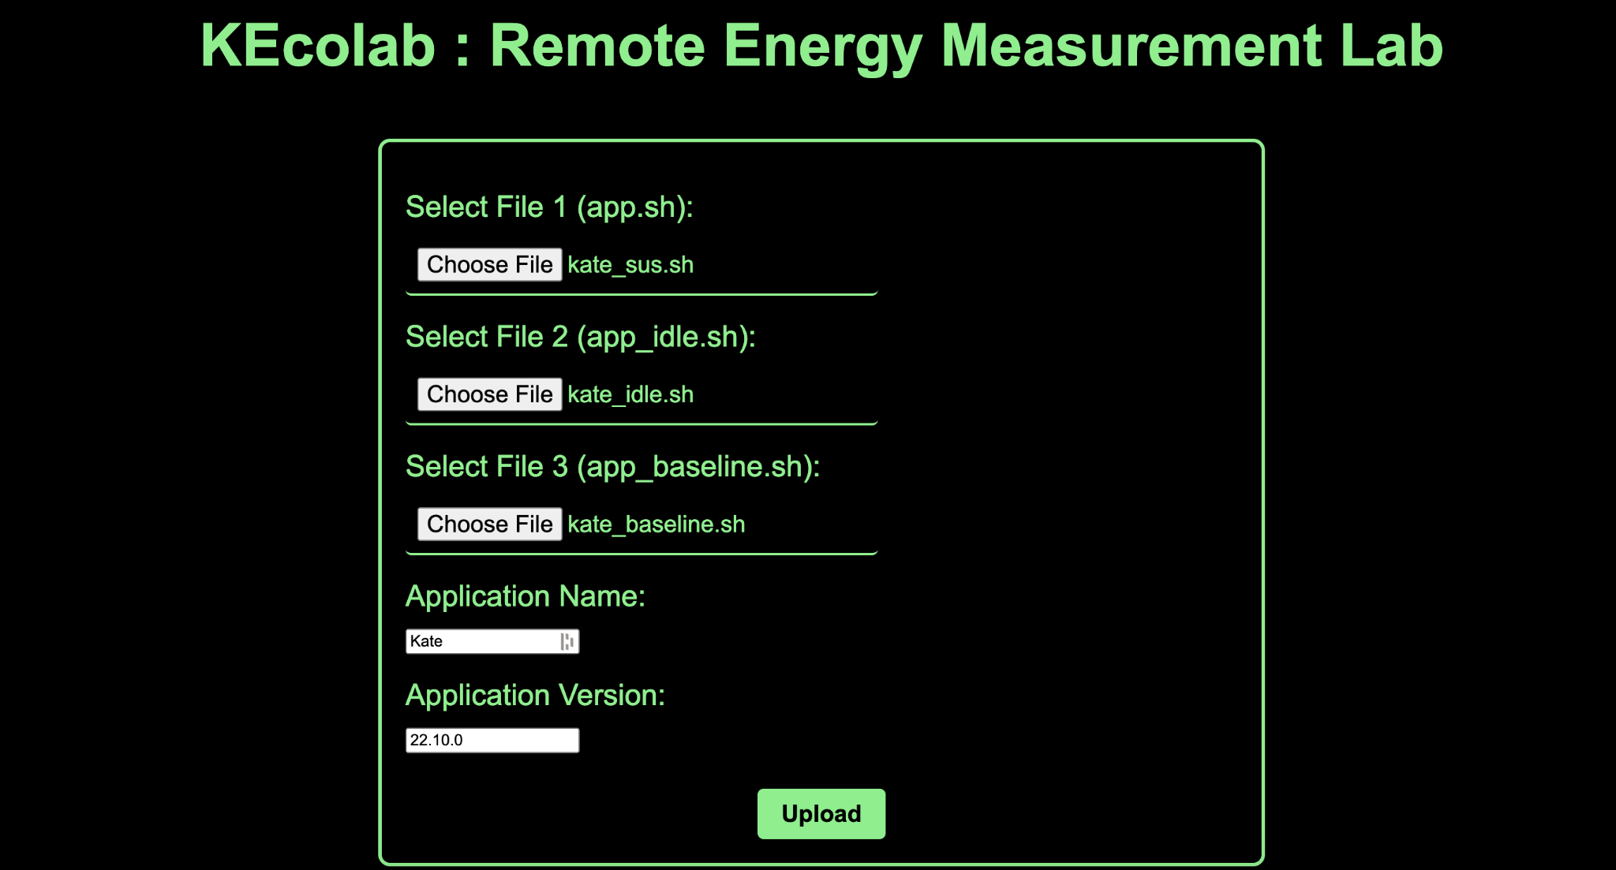

- We can also create user accounts, including measurement history, and add more features to the frontend such as providing instructions on the measurement process.

4. Timeline

Community Bonding Period [May 4 to May 28]
- Discuss the project idea as well as any improvements or edge cases with mentors
- Reach out to developers who are interested in measuring the energy consumption of their software
- Set up my blog for eco.kde.org
- Set up the project repository
- Learn more about CI/CD process

Deliverables Timeline
- Implement a CI/CD Pipeline for automating the energy measurement process [May 28 to July 10]
  - Create stages for each CI job
  - Create build, energy_measurement, and result jobs as part of the CI pipeline
  - Test each job to check if they are working as expected
  - Implement a logging mechanism for debugging purposes of CI jobs
  - Write a blog post about the progress and the results obtained
  - Document the code

- Mid-Term Evaluations [July 10 to July 14]
  - Based on evaluations, implement the required changes

- Implementing Frontend for KECOLAB [July 14 to August 10]
  - Design a minimal frontend for KEcoLab
  - Enable features in KEcoLab like authorization and instructions on how to measure software using KEcoLab
  - Integrate the frontend with Gitlab CI
  - Publish a second blog post with details about progress made

- Buffer Time [August 10 to August 21]
  - Buffer time in the event that something goes wrong
  - Test KDE’s text-editor Kate using the KEcoLab
  - Publish a final blog post
  - Prepare the branch for merging into the master
  - Document the complete code

- Final-Term Evaluations [August 21 to August 28]

5. About Me

I am Karanjot Singh, a sophomore at Jaypee Institute of Information Technology, India. Currently, I am working as an LFX Mentee at Cloud Native Computing Foundation (KubeScape) and also a mentor at Season of KDE 2023. I have been contributing to Free & Open Source projects for many years now, and I have a keen interest in this field. I have been an active contributor to various open-source organizations, such as AWS, Google, Tor Project, and CNCF.
My journey with KDE started in 2022 when I was a mentee in KDE’s annual program Season of KDE. I worked with the KDE Eco project to create Standard Usage Scenarios used for measuring the energy consumption and hardware performance of software. I found the community very helpful, and it helped me to enhance my developer skills and be part of many ongoing projects. I am also part of the Open Source Society of my college, where I regularly give talks and create awareness about the open-source culture.
I program primarly in Python, but I am not limited to it. I have worked on projects in various languages, including Go, Js, Qt, and C/C++.

I have my personal blog on drquark.netlify.app, and you can contact me at @drquark on IRC or KDE’s matrix instance. If I am not available, you can drop me an email at drquark@duck.com, and I will reply within 24 hours. Alternatively, you can try calling me on [Redacted].

Here are some of my profiles on different platforms:
Github
Invent KDE
Twitter

Here are some of my previous contributions to KDE:
Season of KDE 2022 Status Report
KdeEcoTest
Other developer work, such as fixing issues and mentoring in Season of KDE 2023.

COMMITMENT:
In terms of availability, there is no conflict of interest in the coding phase at present, and I do not plan to have any other commitments during Google Summer of Code (GSoC). If there will be any sudden changes in the university schedule, I will discuss them with the mentors. During the university exams, I will give 10-15 hours per week to this project.

